Final Project
Github Portfolio
Name: Palma, Leande Arich D. | Date Submitted: 11/10/2025
Course Code and Title: CPE201A - Computer System Administration and Troubleshooting | Instructor: Ma’am Sayo
1. Objective/s:
This final project aims to demonstrate the student’s ability to create and build a GitHub portfolio by compiling and organizing outputs from other Computer Engineering courses.
2. Intended Leaning Outcome/s:
By the end of this final project, the students should be able to:
- Develop a professional GitHub portfolio that effectively showcases their projects and demonstrates integration of knowledge from various Computer Engineering courses.
3. Directions:
- Create a New Repository
- Log in to your GitHub account.
- Click New Repository.
- Set the repository title as:
CPE201A_FP_SURNAME
- Add a short description, for example: “Final Projects Compilation for CpE Courses.”
- Choose the repository visibility (Public or Private).
- Click Create Repository.

- Prepare Files on Ubuntu Linux
- Open your Ubuntu terminal.
- Navigate to the directory where your final projects are saved.
cd ~/Documents/CpE_Projects
- Organize your project folders according to different CpE courses, for example:
CPE201A_FP_SURNAME/
├── CPE101/
├── CPE102/
├── CPE103/
└── CPE104/
- Make sure each folder contains the corresponding final project files from that course.

- Initialize Git and Push to GitHub
- Verify and Share
- Go to your GitHub repository online and confirm that all files and folders are properly uploaded and organized.
- Copy your repository link and make sure it is accessible (if required, set repository visibility to “Public”).
- Documentation
- Take screenshots of the following:
  - Repository creation page.
  - Organized folder structure.
  - Ubuntu terminal commands during initialization, commit, and push.
  - Final GitHub repository page showing the uploaded projects.
- Compile all screenshots and input it in Section 4. Outputs.

4. Outputs:
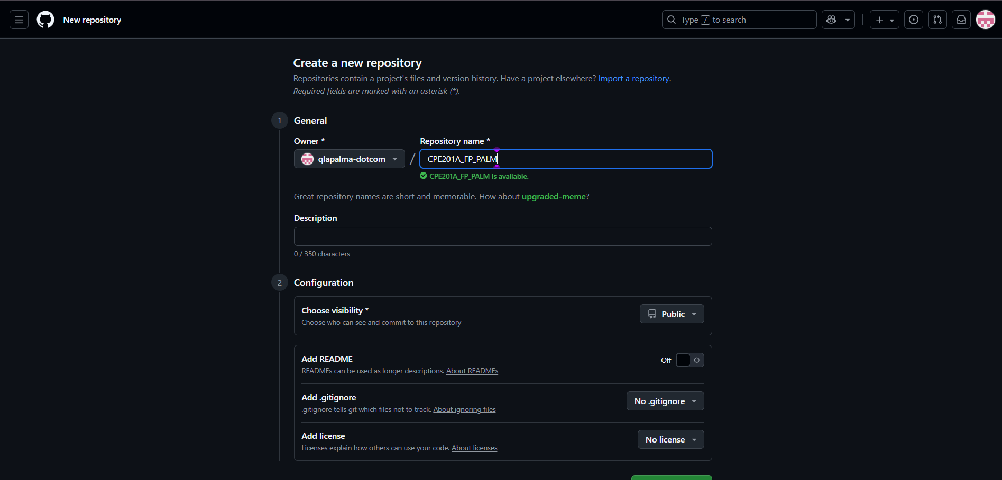
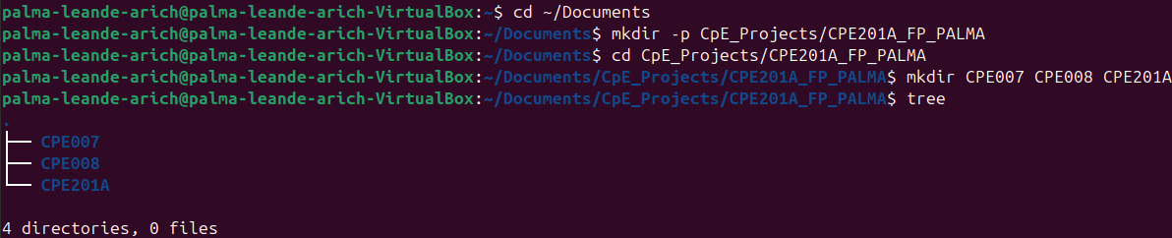

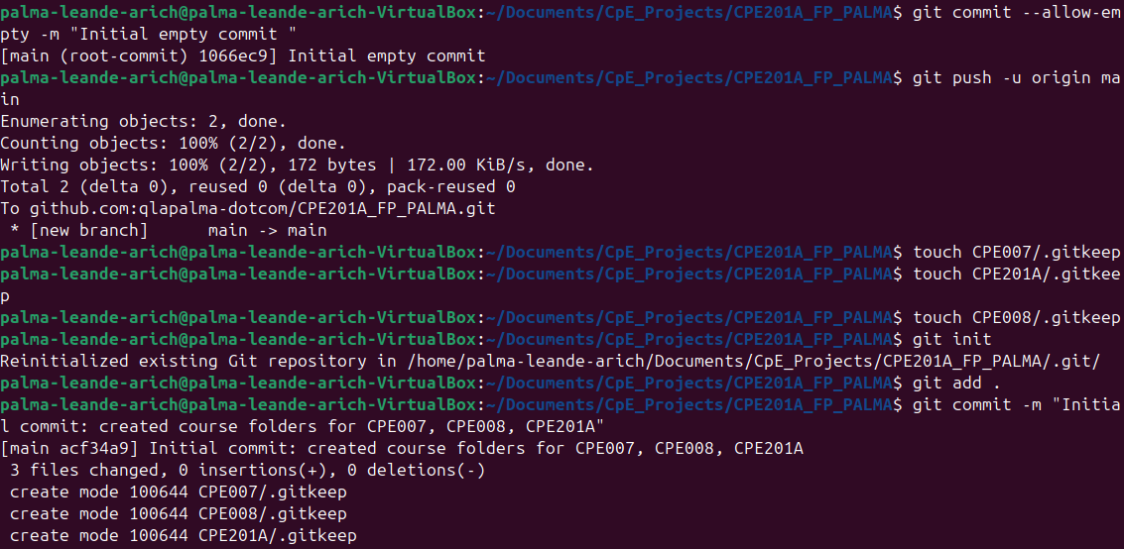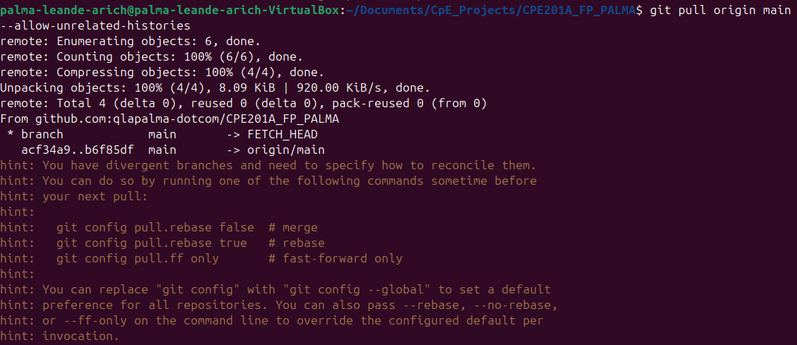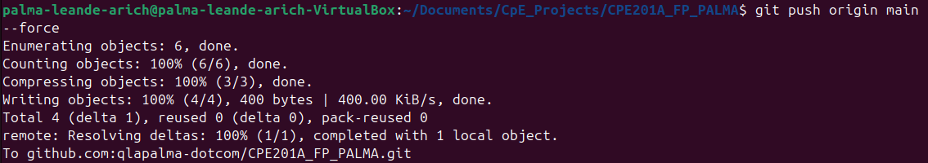

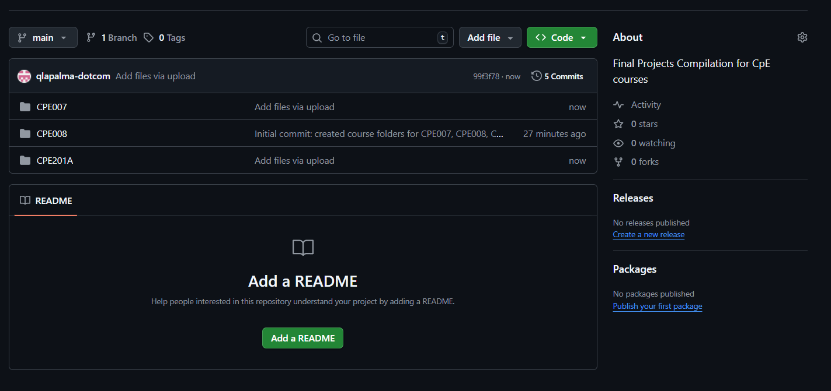
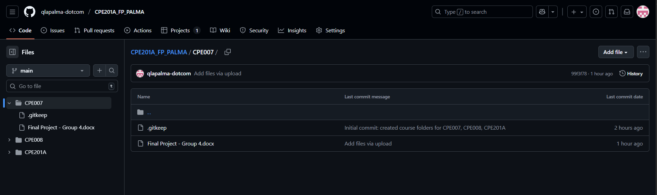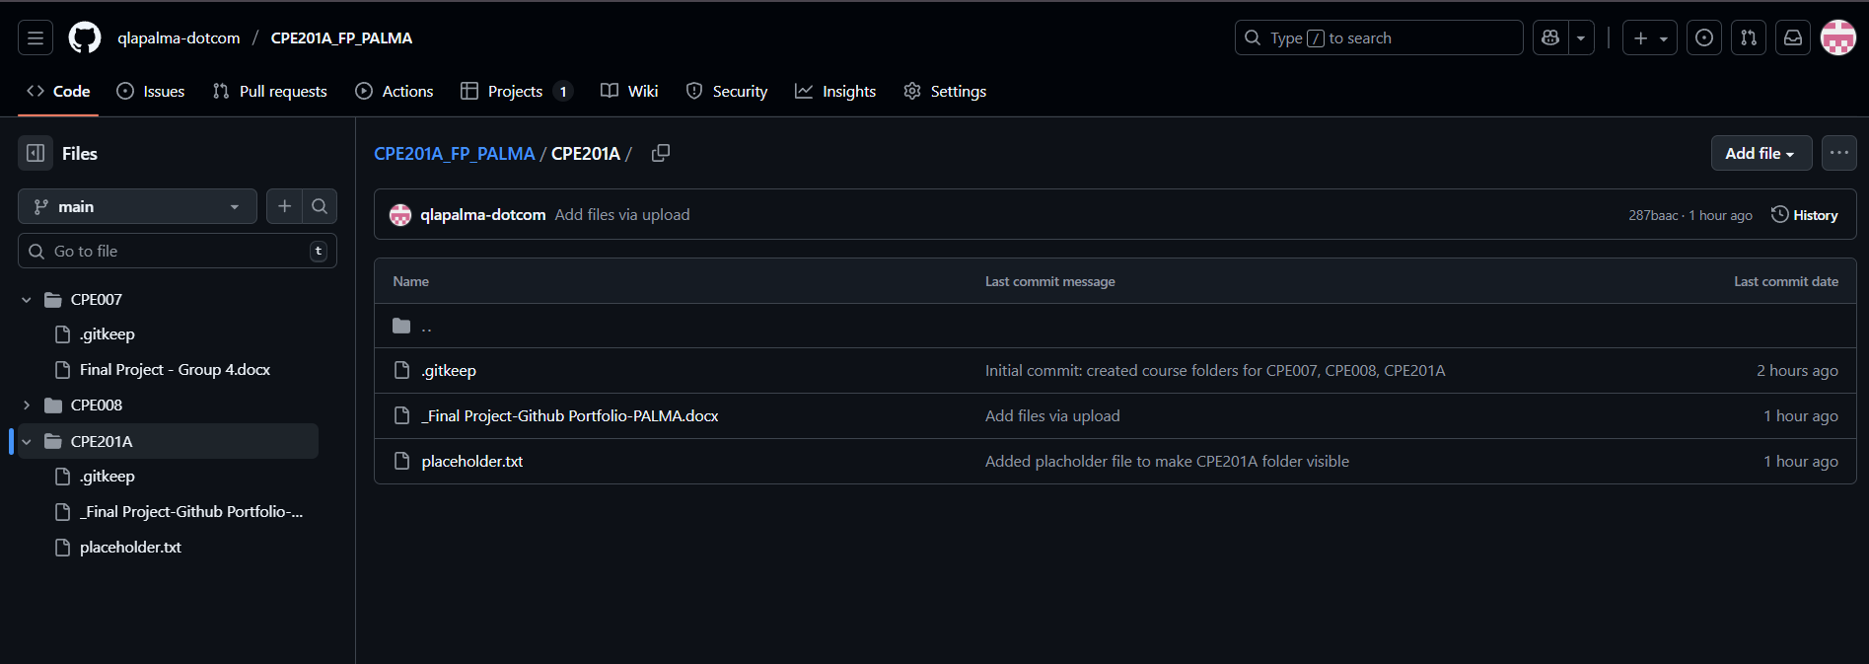

5. Conclusion/Learnings/Analysis:
In this final project, I learned how to create a repository for a portfolio of all the projects for my CpE courses. This activity enhanced my confidence and developed my skills in using Linux commands inside Ubuntu VirtualBox Terminal. Additionally, using the commands, I could create directory folders that I could then connect/add/transfer to GitHub. Lastly, it tested and strengthened my abilities in troubleshooting.
6. Assessment Rubric:
